AI/ML Project: Disease Prediction System using Machine Learning

Project Title: Disease Prediction System using Machine Learning

Project Details:

Domain: Artificial Intelligence and Machine Learning

Project Name: Disease Prediction System

Level: Intermediate

Project Description:

The "Disease Prediction System using Machine Learning" project aims to

develop an intelligent system that predicts the likelihood of a person having a

particular disease based on various health-related features. The system will

utilize machine learning algorithms to analyze historical health data and make

predictions, contributing to early disease detection and proactive healthcare

management.

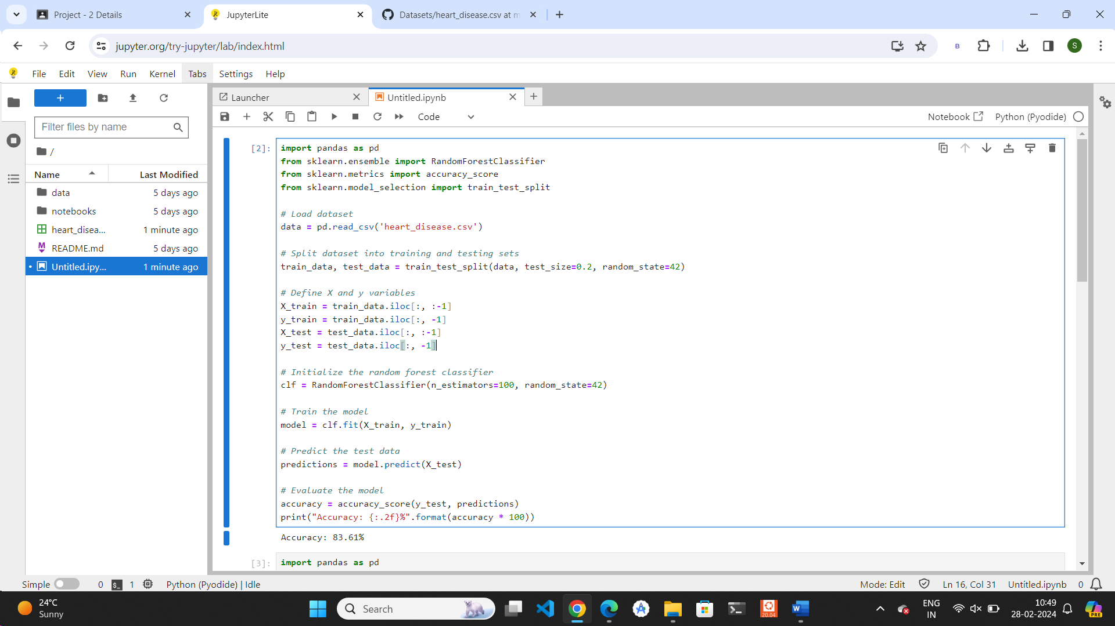

import pandas as pd

from sklearn.ensemble import RandomForestClassifier

from sklearn.metrics import accuracy_score

from sklearn.model_selection import train_test_split

# Load dataset

data = pd.read_csv('heart_disease.csv')

# Split dataset into training and testing sets

train_data, test_data = train_test_split(data, test_size=0.2, random_state=42)

# Define X and y variables

X_train = train_data.iloc[:, :-1]

y_train = train_data.iloc[:, -1]

X_test = test_data.iloc[:, :-1]

y_test = test_data.iloc[:, -1]

# Initialize the random forest classifier

clf = RandomForestClassifier(n_estimators=100, random_state=42)

# Train the model

model = clf.fit(X_train, y_train)

# Predict the test data

predictions = model.predict(X_test)

# Evaluate the model

accuracy = accuracy_score(y_test, predictions)

print("Accuracy: {:.2f}%".format(accuracy * 100))